UNIVERSITY OF MUMBAI

M.Sc. (Computer Science)

PROJECT OF SOFTWARE DEFINED NETWORKING

ON

HOME SECURITY SYSTEM

SUBMITTED TO SUBMITTED BY
Mr. R. K. MAURYA NAME – VIVEK BALU GARJE
ROLL NO. – 12
COURSE – M.Sc. COMPUTER SCIENCE
SEMESTER – SEM I

SR.  NO. | INDEX | PAGE  NO.
1 | INTRODUCTION | 1
2 | INFORMATION
3 | IMPLEMENTATION
4 | COMPOSITION OF PROJECT
5 | OUTPUT
6 | CONCLUSION
7 | REFERENCE

INTRODUCTION

Packet Tracer is a Cisco Systems-designed cross-platform visual simulation application that allows usersto produce topologies for networks and imitate real computer networks. The app enables developers touse a virtual command line interface to emulate the setup of Cisco routers and switches.
Technology plays a critical role in all daily activities of the present day. One of these needs is to create a smart home that controls operation and turns off electronic devices via a smartphone. This implementation can be implemented effectively using package tracking software that includes IoT functions to control and simulate a smart home. IoT technology can be applied to many real life issues, such as: homework, treatment, campus, office, etc. In this paper, the focus is on a safe home system that includes devices such as: air conditioning, alarm, lighting, and doors. Garage that is some of the day to day issues. The aim of this research is to come up with a simulation of smart devices that can be controlled by the end-user smart device remotely and then show the concept called smart home. Use of Cisco Packet Tracking Features Simulated smart home and IoT devices are monitored. Simulation results show that smart objects can be connected to the home portal and objects can be successfully monitored which leads to the idea of real life implementation.

INFORMATION

IOT means "Internet of Things" that defines things and their connections to the Internet (A & K. A) (R. Pivare, M. Tazil 2011). The Internet of Things enables control of local and remote objects by consuming the integration of network technology. IoT connects devices around us as well as over the Internet and automates communications (Moinar, Shamsi, and Navar, 2012).
Groups of scientists and organizations have attempted to clarify the Internet of Things and define their proposed definition as [Halleret al] "a world where material things are seamlessly integrated into the information network and where material things can become an active participant in the business process." With the emergence of life changing
on the Internet, the Internet of Things is expected to have a huge impact on life (Iova,2014).
Cisco packet tracer is a cisco multi-platform simulation tool to allow learners to simulate networks. It also helps generating IoT reformations. In our research work we used the latest version of cisco packet tracer. Fig 1 shows its interface.
Some of the objectives of cisco packet tracer are:
- Allows students to design complex networks
- Can be used a learning aid among students
- Allows students to explore IoT concepts
- Allows users to build, design and configure smart city and smart home by providing a different intelligent object that uses them.
- Provides realistic visualization and simulation of IoT devices
Cisco Packet Tracer interface
This research paper is organized into a number of sections which include literature review of related works, followed by methodology used in this development. Further the safe home implementation procedures and results are discussed. Finally the conclusion and references are included.

IMPLEMENTATION

- METHODOLOGY
The idea of smart is very catchy and review on similar researches was conducted to understand its concepts and its architecture. As implemented by majority of researchers, cisco packet tracer was used for implementing smart home. The newly released cisco version was used as it supports home security features as well as provides programmng environment besides networking features. The different programming languages supported are visual basic, java scripts, and python. Smartphone and home gateway are used to control the devices such as smart window, smart fan, smart garbage and sensor. The smart devices are connected to the IOT home gateway ports and smart phone is used to communicate with the smart devices.
- SAFE HOME DEVELOPMENT
Home gateway has four Ethernet ports and wireless access point configured with the "Home Gateway" service set identifier (SSID). All the devices are connected to gateway using config menu in each device, the name of the gateway has to entered. This can be repeated to all sets of devices that has to be controlled in a home gateway. Ip config menu displays the lidt of devices connected to the home gateway. The smart phone is used to control all the devices.
The cisco packet tracer interface provides inbuilt devices to be added in the network. The first step is to select home gateway device from the network devices. To authenticate and validate the wireless connection, we also can configure home gateway with WEP/WPA-PSK /WPA2 protocols.
The second step in simulating a smart home is to connect devices to the home gateway. In this work, six wireless devices were coupled with the home gateway. The devices configured included fan, webcam, door, air condition, garage and motion detector. Figure 2 shows the smart objects connected in our system which included only wireless devices.

COMPOSITION OF PROJECT

Smartphone specification in workspace
The next step is to add rules and conditions for the smart objects to give notifications or alarm. In order to do this, from smartphone select the desktop tab and click IoT monitor.
IOT monitor to home gateway.
When IOT monitor is selected, the rules can be added, click conditions then click add to add new activities such as lock door condition as shown in Fig 8 and Fig 9 shows the rules written for controlling door.
- Door rules.
Different conditions and rules are programmed based on the smart object connected to home gateway. These steps have to be repeated for all objects.

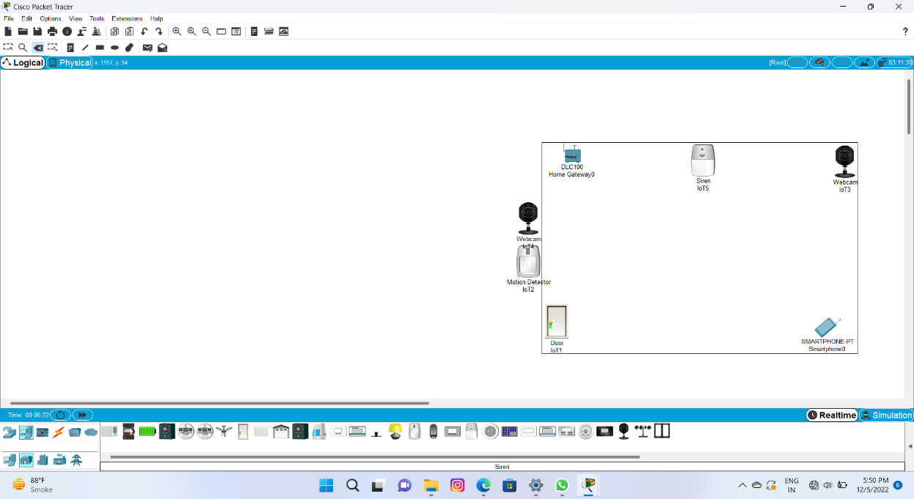

SETUP 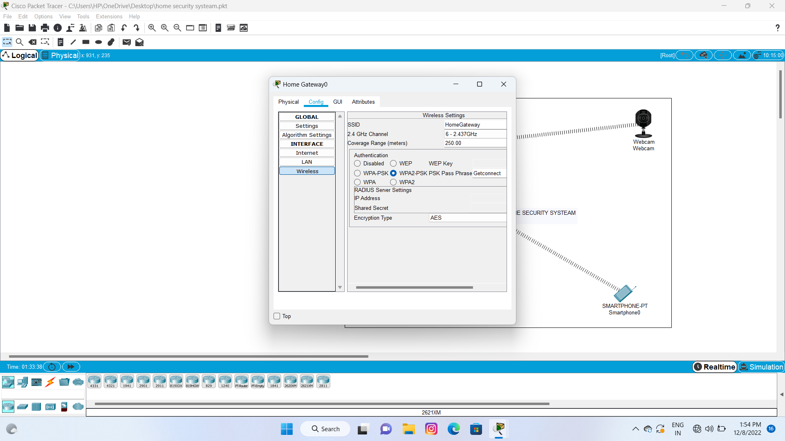

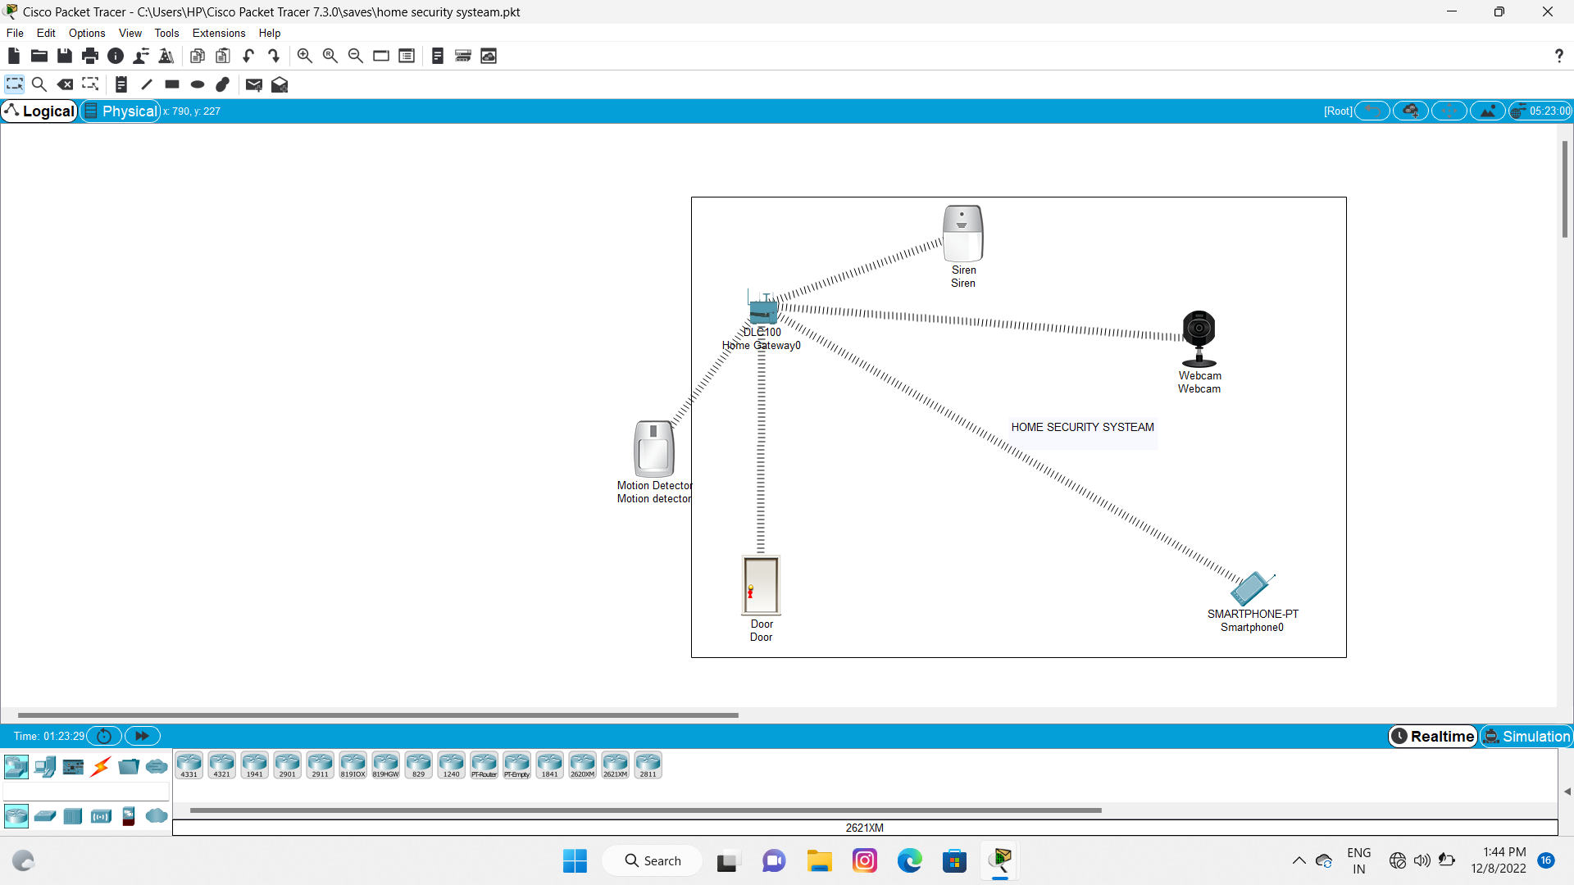

OUTPUT

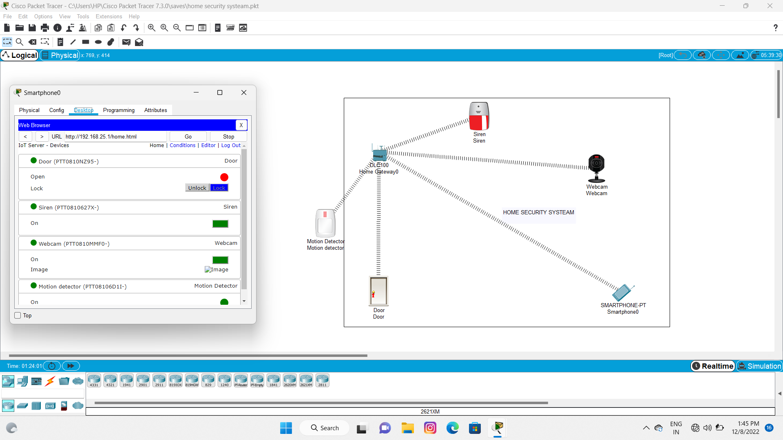

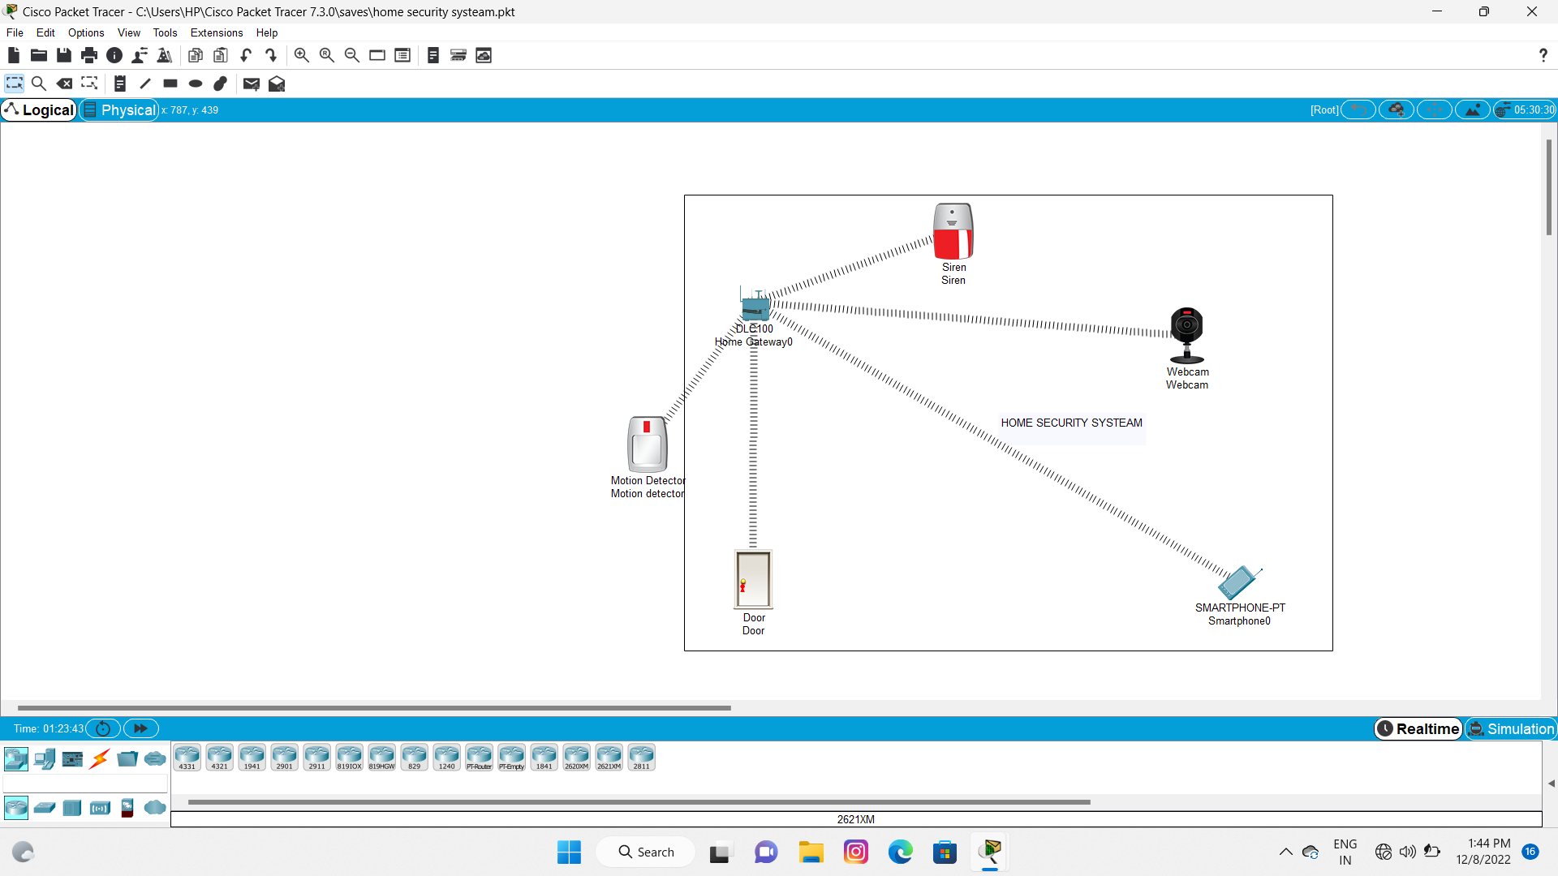
CONCLUSION
The aim of this research was to simulate smart home. The technology innovation and the hike in smartphone usage was the motivation behind this work. The security measures are very critical and IoT is providing a new and excellent concept on make our surroundings smarter.
The result showed that the devices can be controlled and monitored using end user device. Cisco packet tracer gives various facilities which makes simulation easy.The results proves that there an opportunity to apply this model in real life. IoT concept can be applied in various domains.
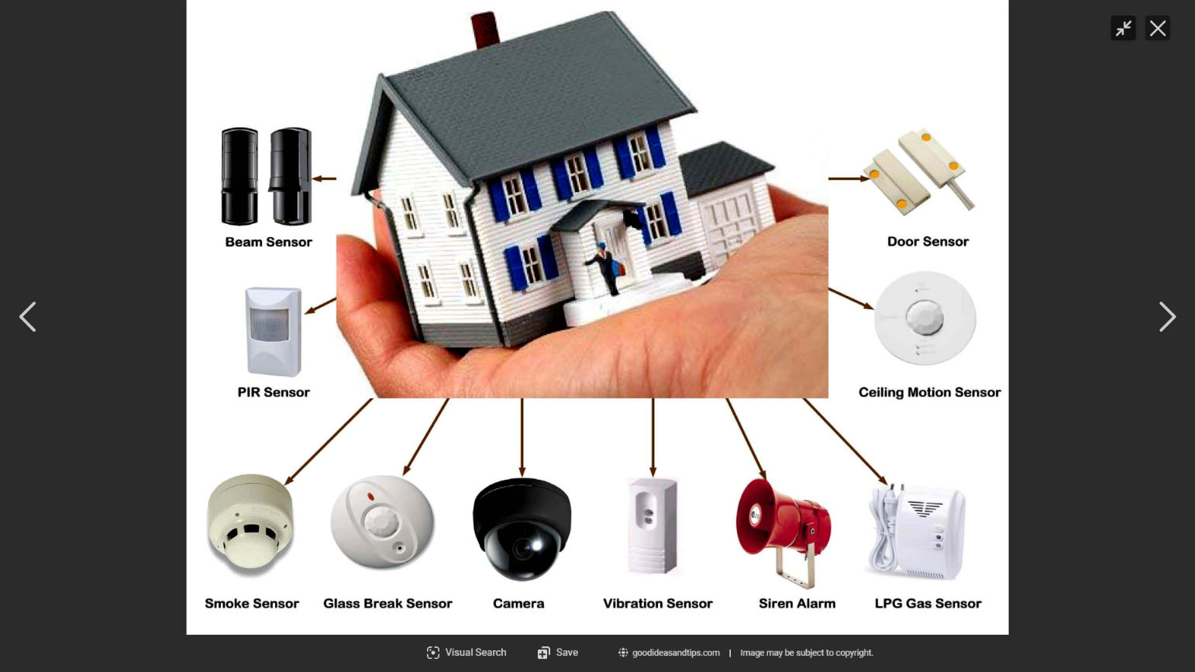

REFERENCE
Google
Help:Link - Wikipedia
(13) Home - YouTube

